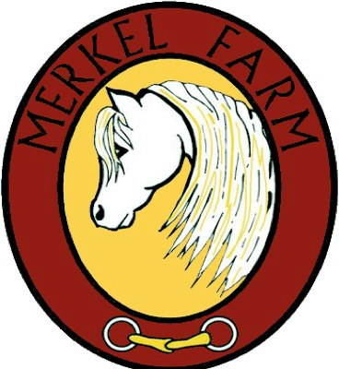

Release of Liability for Rider and Student
This RELEASE OF LIABILITY is made and entered into on the ____ day of ____, 20__, by and between Stephanie Serenati-Merkel owner of the Merkel Farm Equestrian Center, heir in after designated as OWNER, and ______________________, here in after designated as RIDER/STUDENT, and if Rider/ Student is a minor, Rider’s / Student’s parents or legal guardian, ________________________. In consideration of the use, today and on all future dates, of the Owner’s horse(s), property, facilities, and services (including lessons, Day Camps, ManeStream Therapeutic Riding Program, traveling to and from horse shows, and trail rides), the Rider / Student, his or her, successors, assigns, and legal representative, herby expressly agree to the following:
- Rider / Student has inspected the property and the facilities of the Owners, and understands that the property and facilities of the Owners shall be open to the Rider/ Student’s continued inspections for the period of this release of liability.
- Rider / Student shall carry full and complete insurance coverage on his horse, personal property, and himself.
- RIDER / STUDENT ASSUMES ANY AND ALL RISK INVOLVED IN OR ARISING FROM RIDER’S USE OF/OR PRESENCE UPON OWNERS’ HORSE(S), PROPERTY, AND FACILITIES, including without limitation, the risk of death, bodily injury, property damage, falls, kicks, bites, collisions with vehicles, horses or stationary object, fire or explosion, the unavailability of emergency medical care, and/or the negligence or deliberate act of any person. Rider / Student fully understanding that the activity of mounting, riding, boarding, feeding, or even being near a horse, involves numerous dangers and risk of injury to the Rider / Student and others.
- Rider / Student shall hold Owners and all of Owner’s heirs, successors, assigned, franchisees, affiliated, employees and agents completely harmless and not liable, and release them from any and all liability whatsoever, and AGREES NOT TO PURSUE LEGAL RECOURSE against them on account of or in connection with any claim of action, injuries, damages (including incidental or consequential damages), cost or expense arising out of Rider’s / Student’s use or presence upon Owners’ horse(s), property and facilities, including without limitation, those based upon death, bodily injury and/or property damage.
- Rider / Student agrees to waive the protection afforded by any stature or law in any jurisdiction whose purpose, substance and/or effect is to provide that a general release shall not extend to at the time of executing the release.
- Rider / Student shall indemnify and defend Owners and all Owner’s heirs, successors, assigns, franchisees, affiliates, employees, and agents against, and hold harmless from any and all claims, causes of action, damages, judgements, cost or expenses, including attorney’s fees, which in any way arise from Rider’s / Student’s use or presence upon the Owner’s horse(s), property and facilities.
- Rider / Student shall abide by all of Owner’s rules and regulations, including but not limited to:
  - Rider / Student will wear safe riding attire, including long pants, riding boots or shoes with a heel and sole that not contain a deep tread, and an equestrian helmet that meets or exceeds ASTM/SEI certified safety standards;
  - Riding in a safe manner appropriate for horse and rider’s abilities and temperament, weather, terrain, visibility, and ground conditions;
  - No riding through occupied pastures, landscaped areas, lawns and/or planted fields; and
  - No riding near house, barns, vehicles, farm equipment, traffic, pedestrians and/or farming activities.
- Rider / Student is using own horse, the horse shall be free from infection, contagious and/or transmissible diseases. Owner reserve the right to refuse hose if not in proper condition and/or deemed dangerous or undesirable.
- Owners reserve the right to restrict or terminate, without advance notice, Rider’s / Student’s use of and/or access to all or portions of Owner’s property. For purposes of this agreement, either of the Owners may act independently upon behalf of both Owners. In addition, Owners; designated representative (i.e., their stable manager) may restrict or terminate, without advance notice, Rider’s / Student’s use of and/or access to all or portions of the Owners’ property.
- This contract is non-assignable and non-transferable, and is made and entered into the State of Maryland, and shall be enforced and interpreted under the laws of this state. Should any clause be in conflict with State Law, then that clause shall be modified to the minimum extent necessary to render it not in conflict with State Law, and in its modified form, shall be enforceable and enforced. When the Owners and Rider / Student and/or his parent or legal guardian (if Rider / Student is a minor) sign this contract, it will be binding on both parties, subject to the above terms and conditions.

__________________________________ ______________________________
Stephanie Serenati-Merkel, Owner Date

__________________________________ ______________________________
Rider / Student or Parent / Legal Guardian Date

